**GOVERNMENT DEGREE COLLEGE**

**GUMMALAKSHMIPURAM**

**World Ozone Day**

**World Ozone Day 16-09-2023**

**The Department Of Sciences Celebrated Ozone Day in this College on sep-16-2023. In the meeting Sri D. Ramaiah attend as a Chief Guest , he spoke the importance of ozone layer and also explained for protecting ozone layer we plant more trees , to prevent cutting trees etc,,,**

**After Meeting we began the Rally along with staff and students to Elwinpeta Junction. This student gave slogans on the importance of the ozone layer. NSS PO B. Trinadha, Science Department lecturers co- Coordinator T. Satya Rao, and all faculty members and students Participated in this activity.**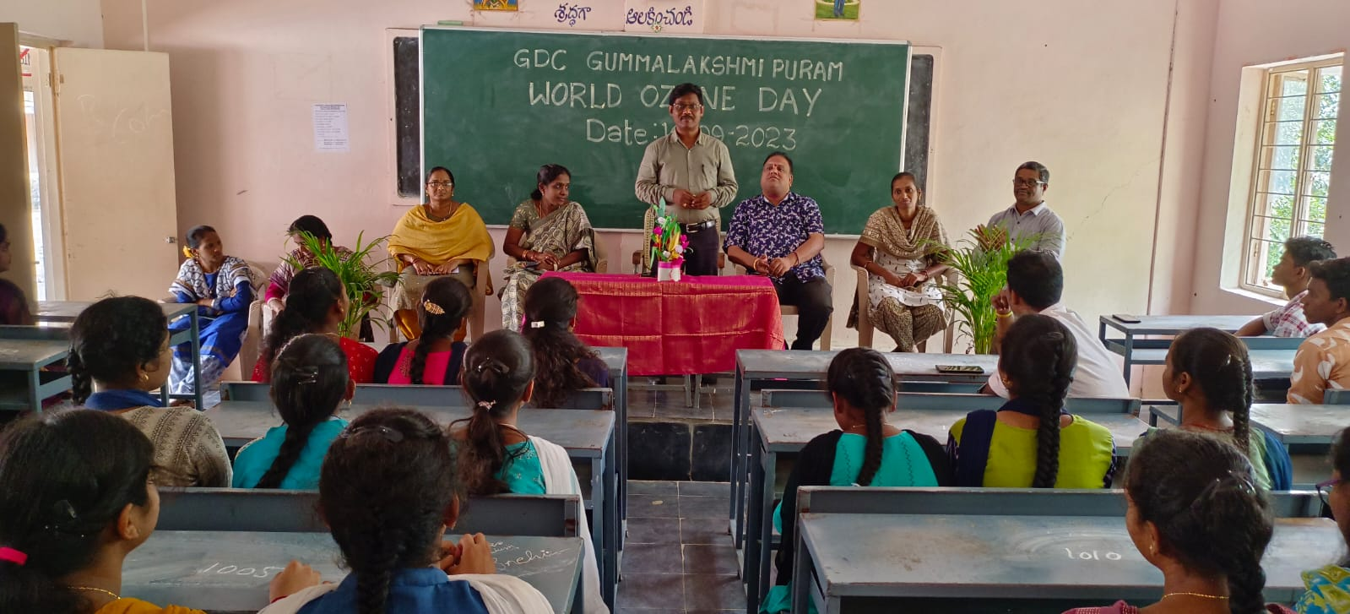

**Speech given by D. Ramaiah (In charge Principal)**

**Speech given by Dr. N. Santha Lecturer in Zoology**

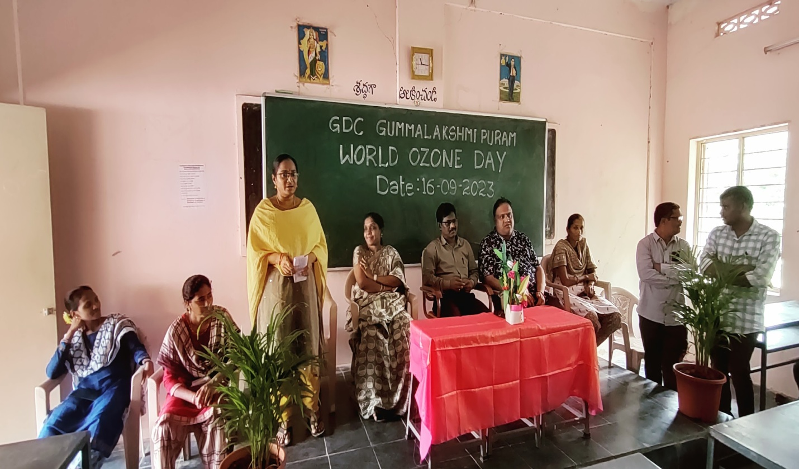

**Speech given by N. Sreekanth Lecturer in Physics**

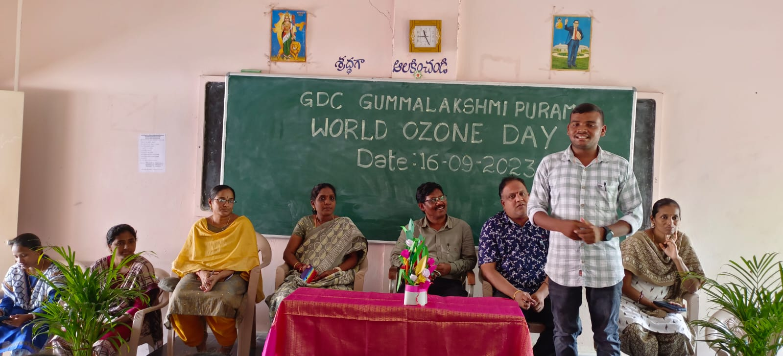

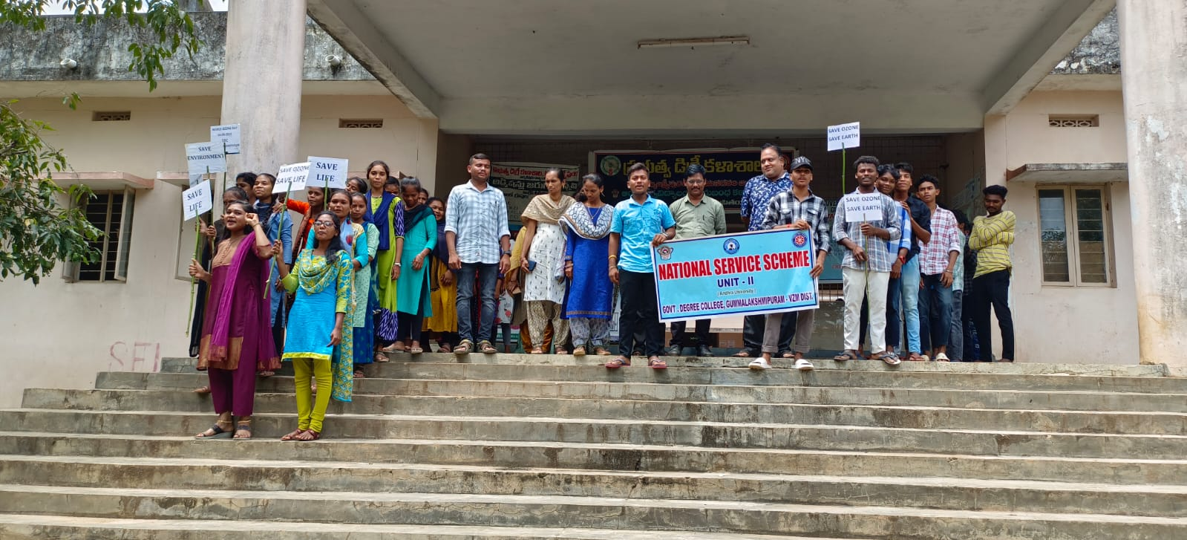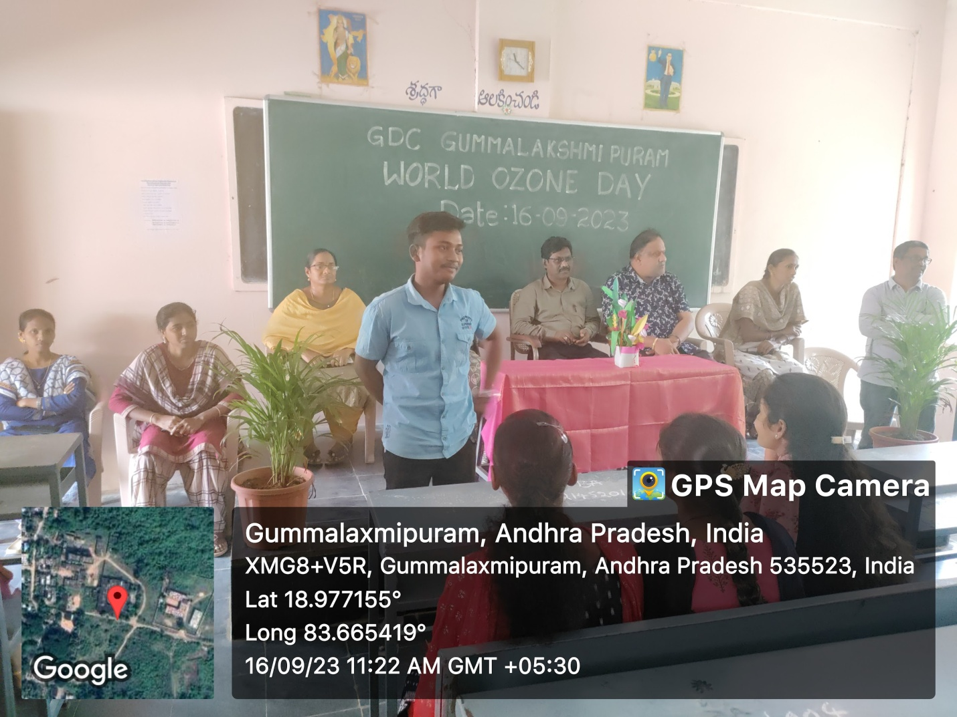

**Speech given by Student M. Jeevan**

**Speech given by Student N. Kishor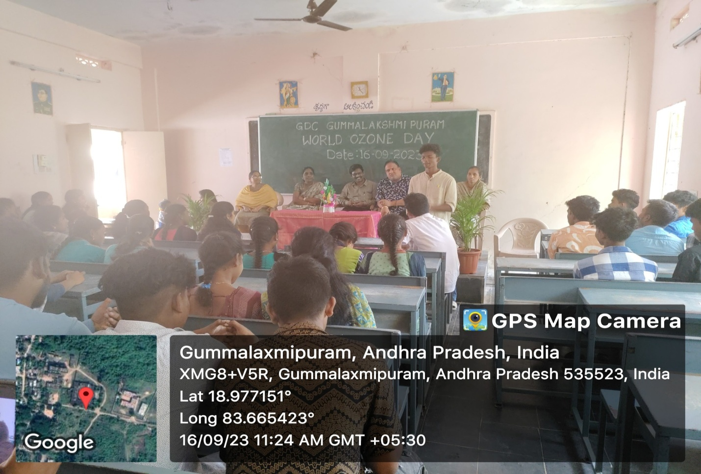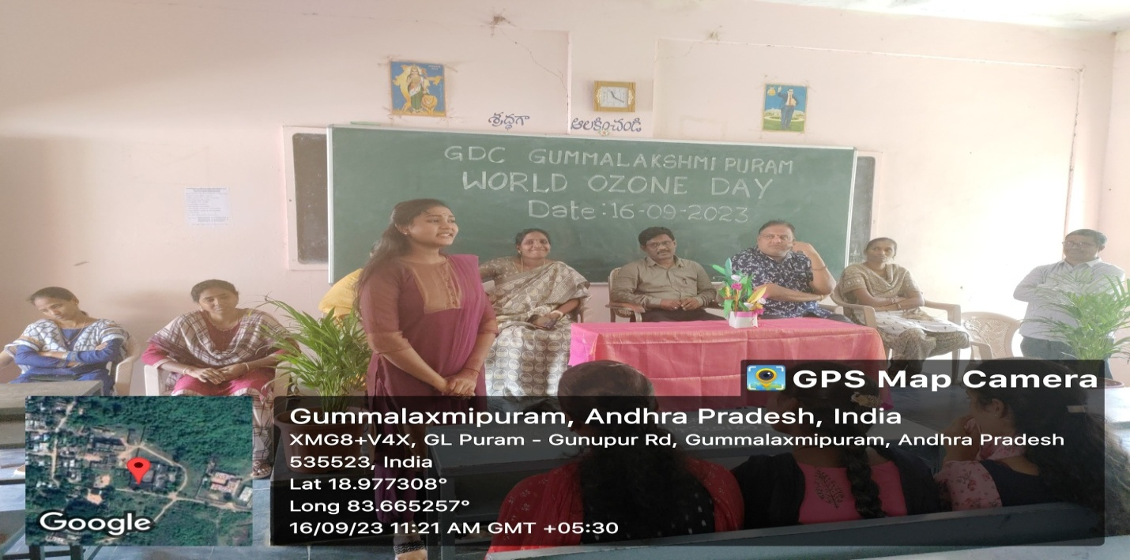Speech given by Student M. Padmini**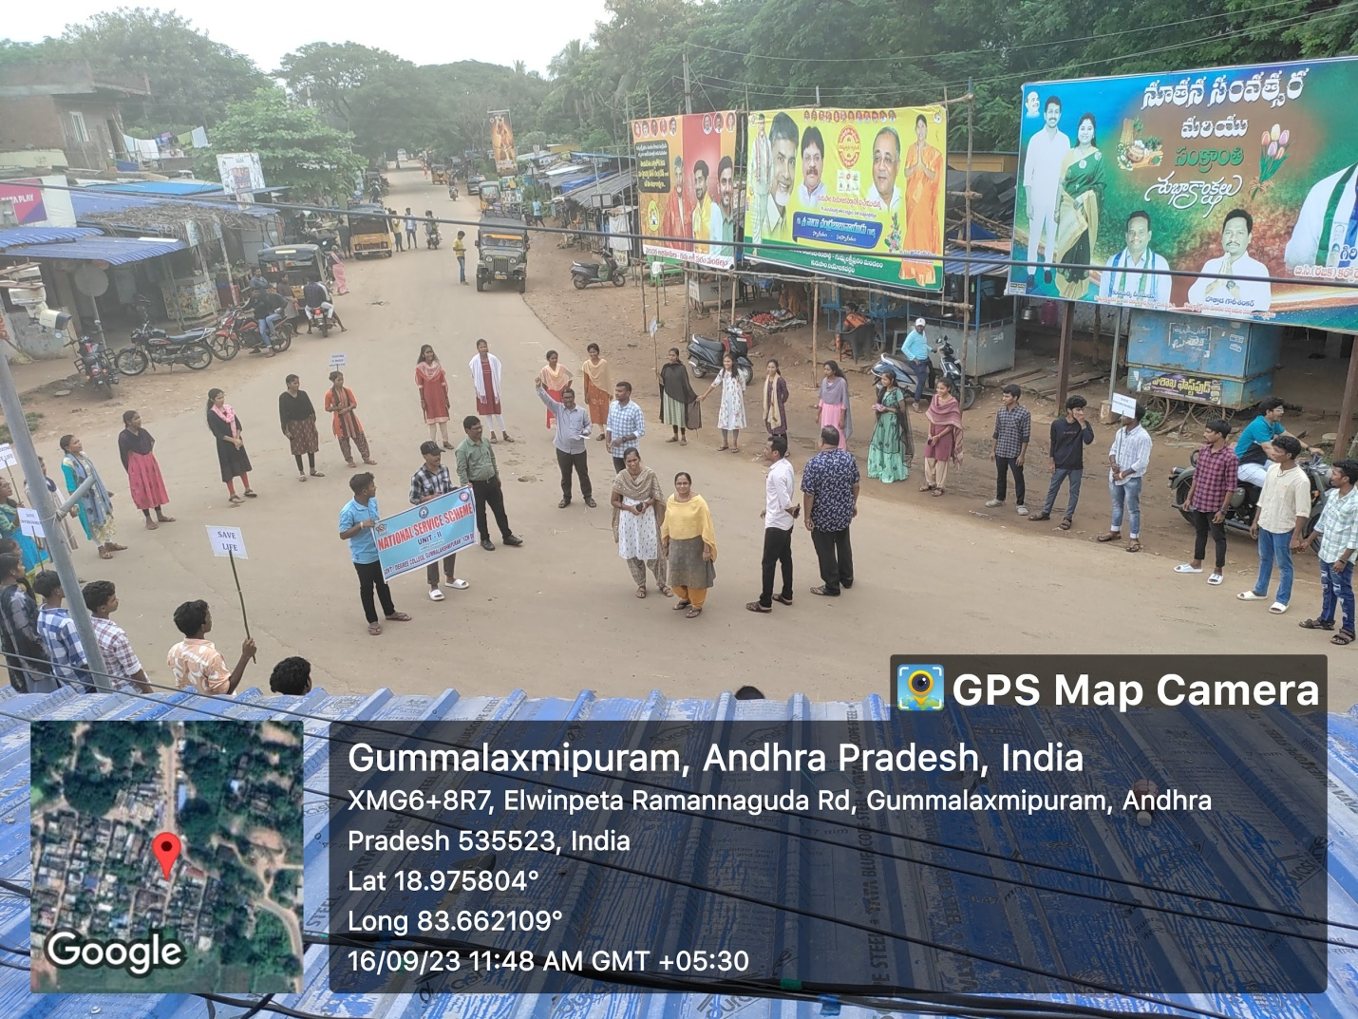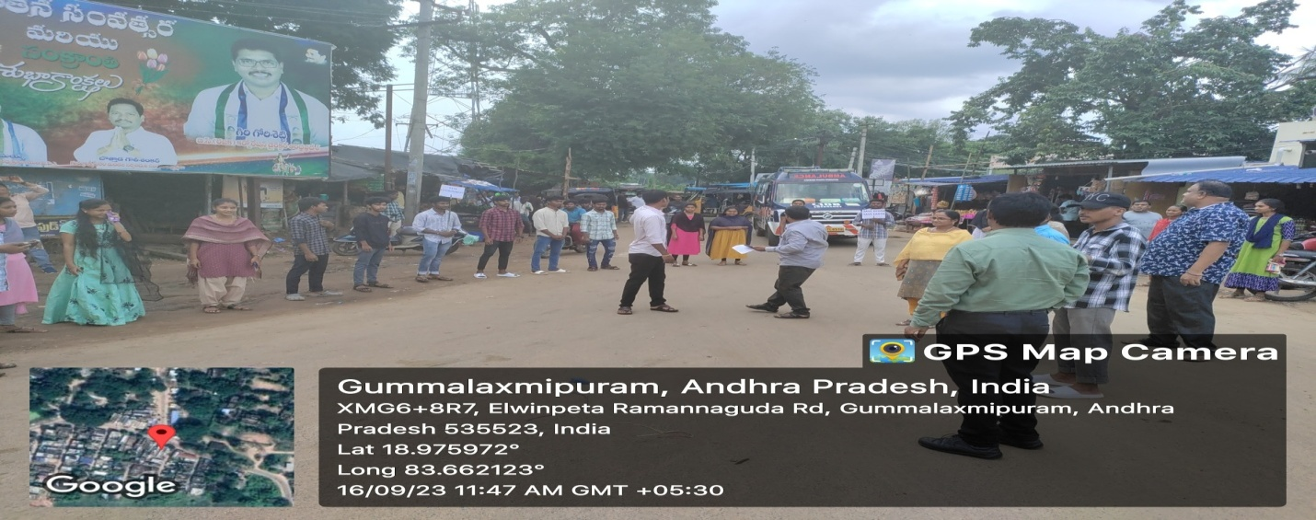

**Ozone Day Rally at Elwinpeta Junction**

